**USECASE 3**

**A Walk Through of Core Azure ServicesSOP**

**Creating a Virtual Machine:**

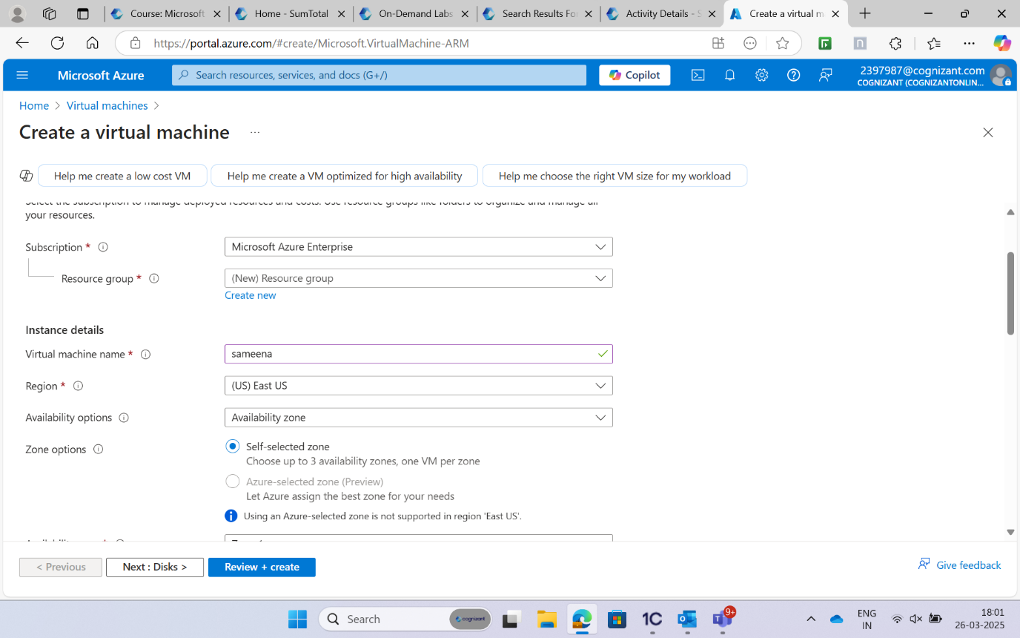

**Validation passed:**

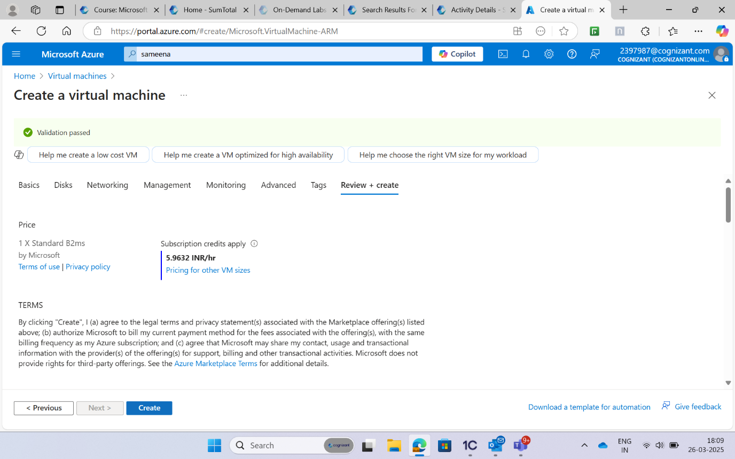

**Deployment is complete:**

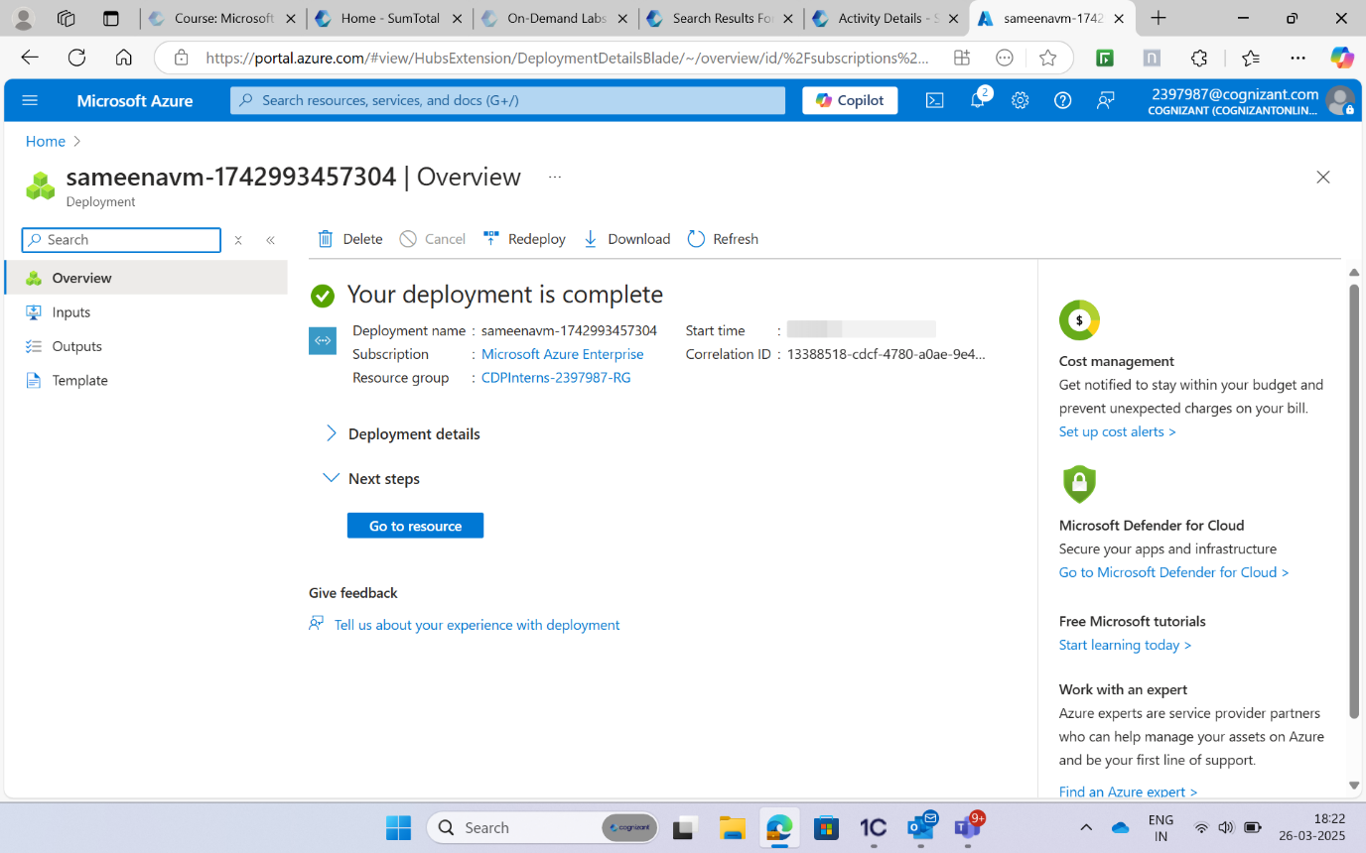

**Connect to the VM & Download RDP file:**

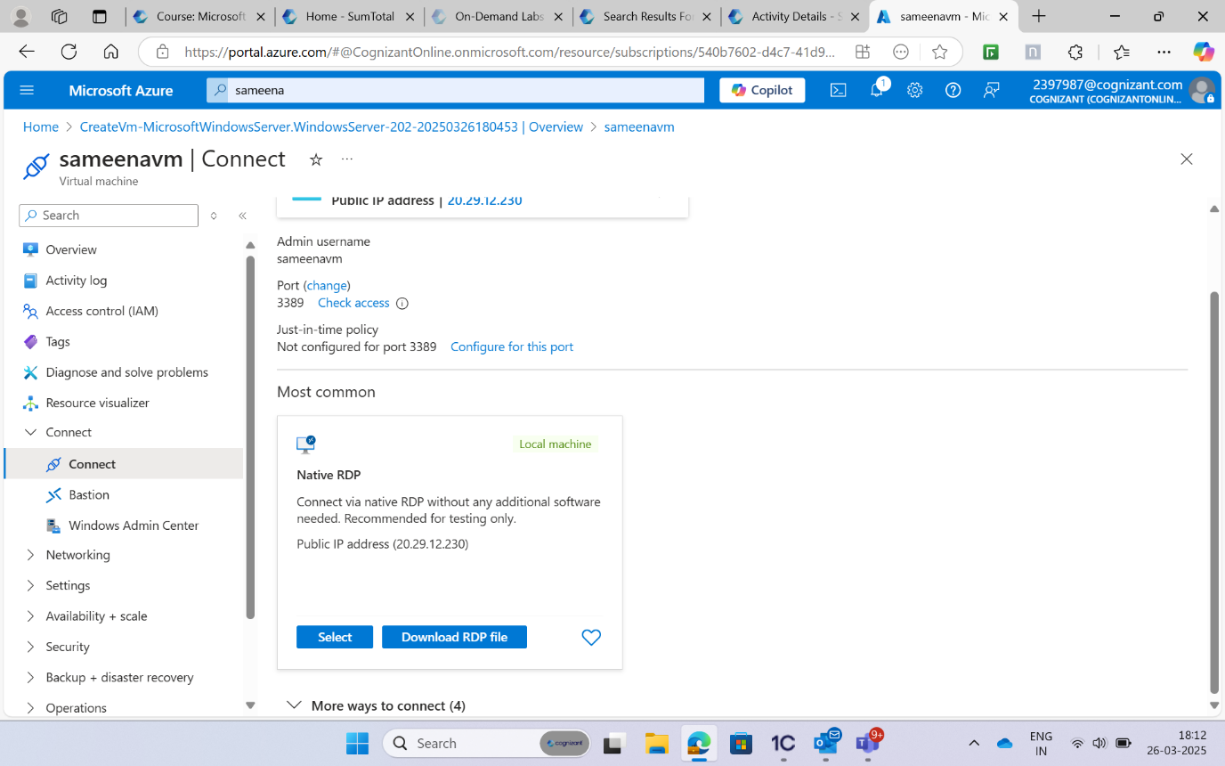

**Creating a storage account and Click Create :**

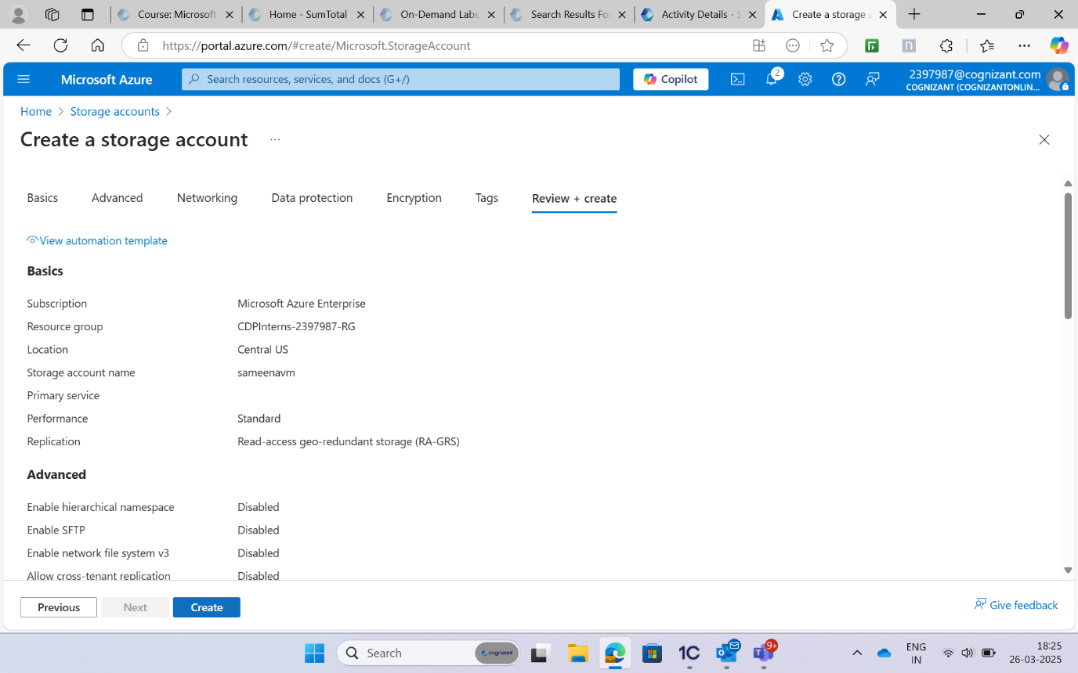

**Navigate to the Storage account:**

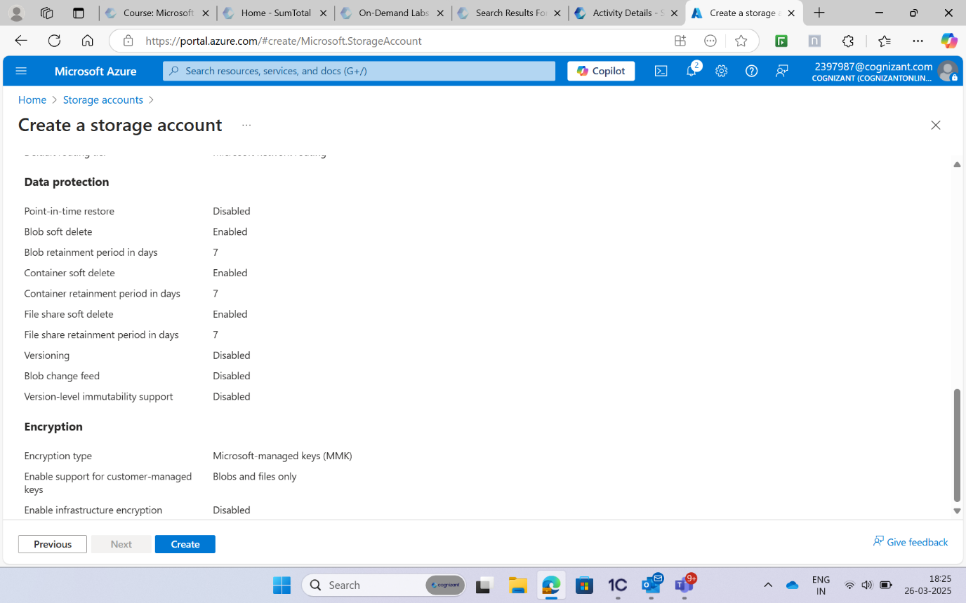

**Creating a Virtual Network:**

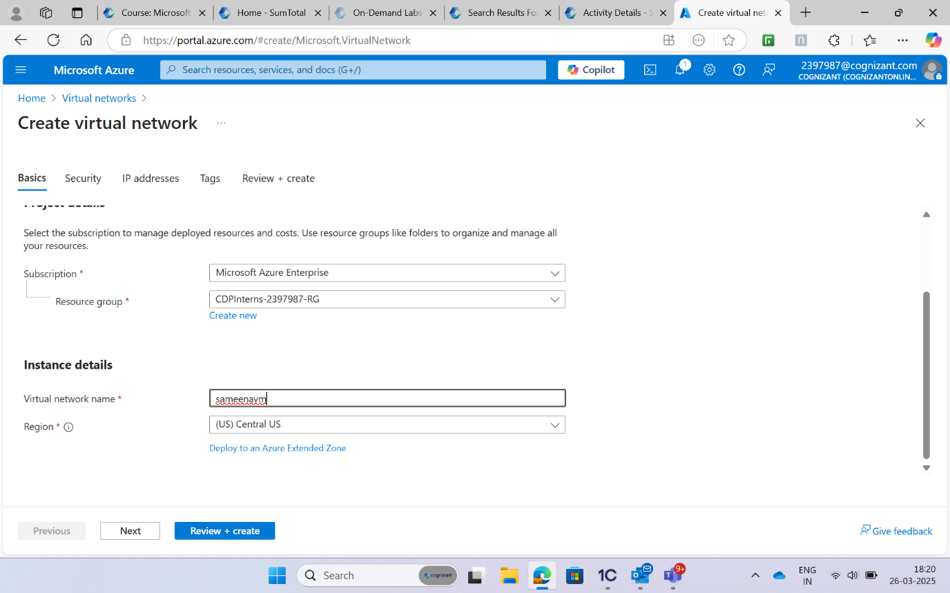

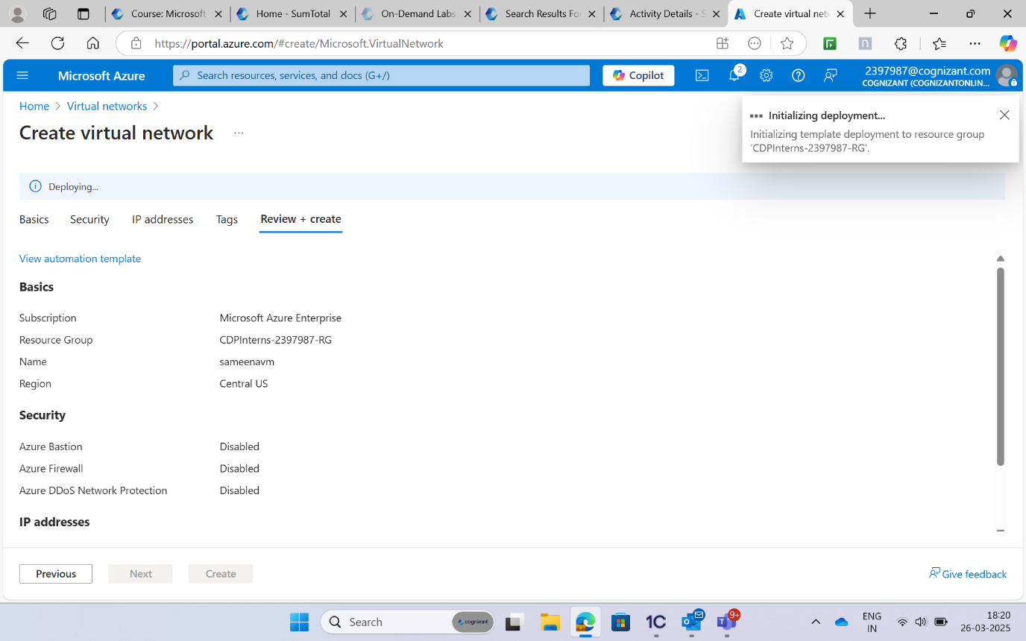

**Deployment is complete and Navigate to the Virtual network:**

